
Agile Development Process and Devops Lab
Assignment -9
NAME = Pallab Das
REGISTRATION NUMBER = 24MIS0212
COURSE CODE = ISWE406P
COURSE NAME = Agile Development Process and Devops Lab
FACULTY NAME = Sweta Bhattacharya
Question 1:
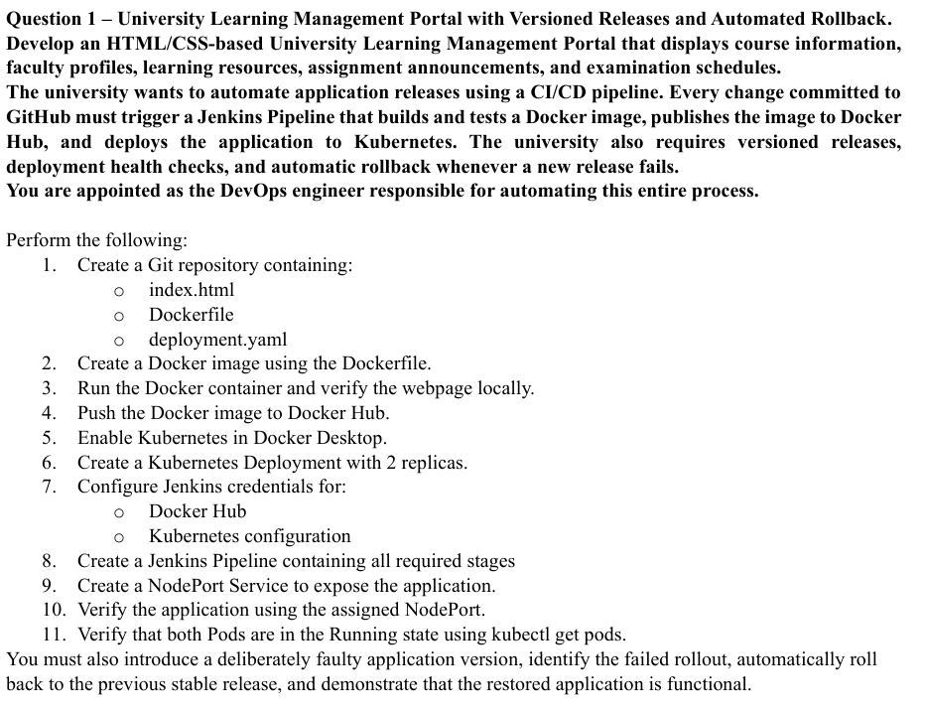
Github Url: https://github.com/PDGamerSG/24MIS0212-Lab-Assessment-9
Step 1: Writing the code
University Learning Management Portal was created using HTML and CSS. The source, Dockerfile, Kubernetes files and Jenkinsfile are stored in the lms-portal folder.
Code: deployment.yaml file
apiVersion: apps/v1
kind: Deployment
metadata:
name: lms-portal
namespace: assessment9
spec:
replicas: 2
revisionHistoryLimit: 5
progressDeadlineSeconds: 60
strategy:
type: RollingUpdate
rollingUpdate: {maxUnavailable: 0, maxSurge: 1}
selector:
matchLabels:
app: lms-portal
template:
metadata:
labels:
app: lms-portal
spec:
containers:
- name: lms-portal
image: pdgamersg/assessment9-lms:v2
imagePullPolicy: IfNotPresent
ports:
- containerPort: 80
resources:
requests: {cpu: 10m, memory: 16Mi}
limits: {cpu: 250m, memory: 64Mi}
readinessProbe:
httpGet: {path: /healthz, port: 80}
initialDelaySeconds: 2
periodSeconds: 3
livenessProbe:
httpGet: {path: /healthz, port: 80}
initialDelaySeconds: 5
periodSeconds: 10
service.yaml
apiVersion: v1
kind: Service
metadata:
name: lms-portal
namespace: assessment9
spec:
type: NodePort
selector:
app: lms-portal
ports:
- port: 80
targetPort: 80
nodePort: 30081
Dockerfile
FROM nginx:1.27-alpine
COPY nginx.conf /etc/nginx/conf.d/default.conf
COPY . /usr/share/nginx/html/
EXPOSE 80
HEALTHCHECK --interval=10s --timeout=3s --retries=3 CMD wget -q -O - http://127.0.0.1/healthz || exit 1
index.html
The page displays course information, a faculty profile, a downloadable learning guide, the assessment announcement and the examination schedule.
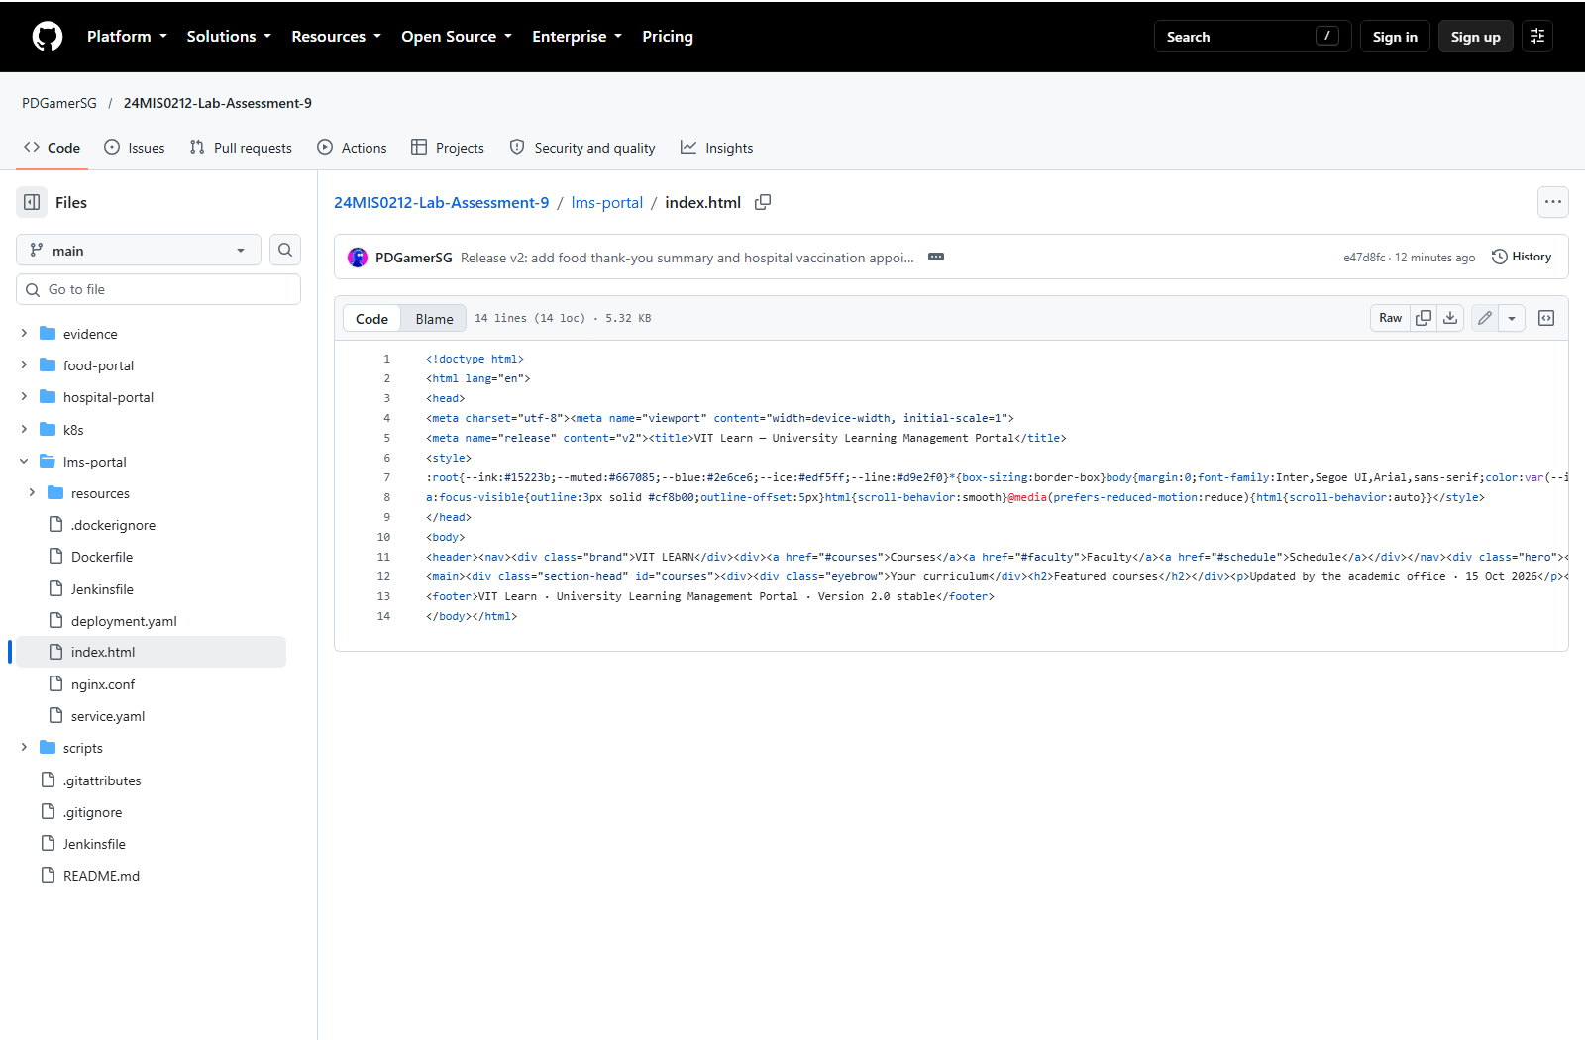
Step 2: Pushing the code to github
One GitHub repository was used for all three questions. The main branch contains the application files and the complete CI/CD implementation.
Commands used:
git add .
git commit -m "Implement reliable portal delivery"
git push origin main
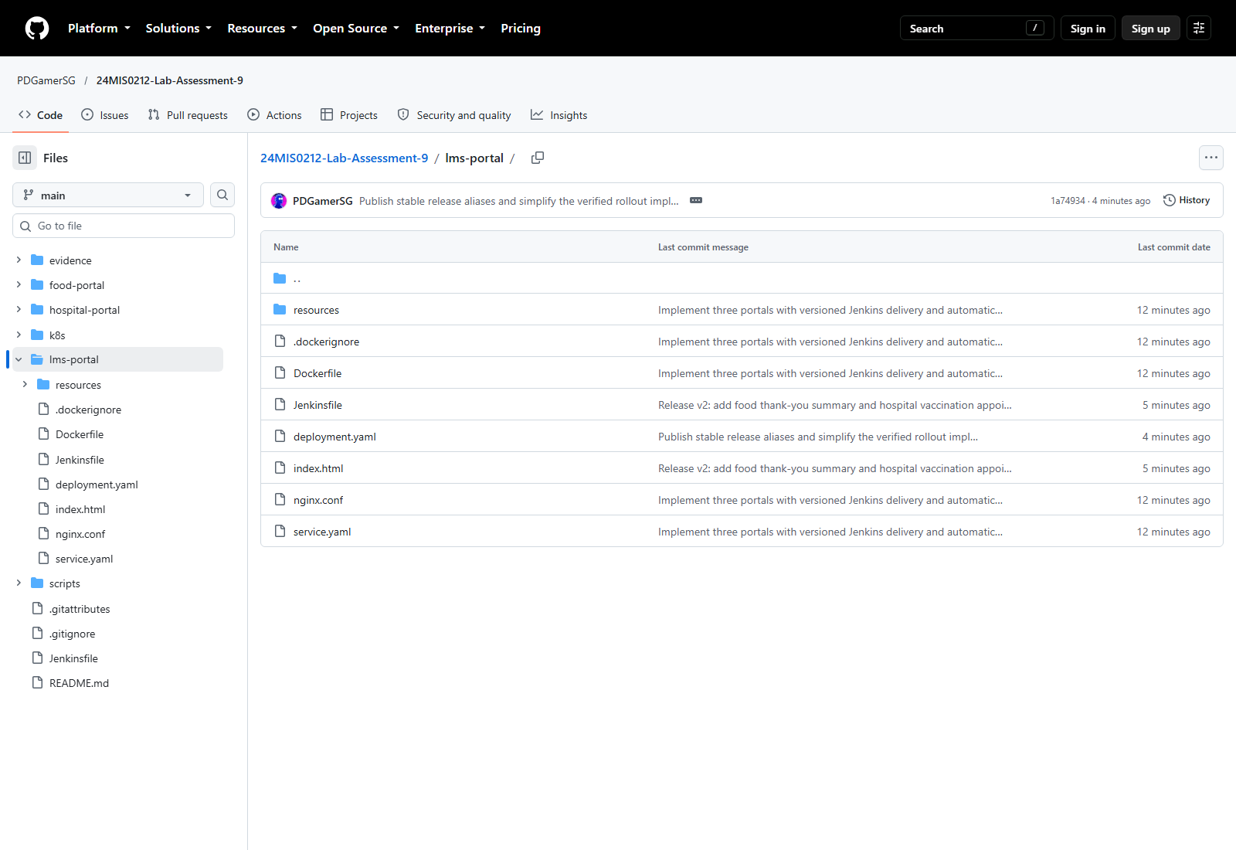
Step 3: Setting up Jenkins
Jenkins uses dockerhub for Docker Hub and assessment9-kubeconfig for Kubernetes. It reads main and polls GitHub every two minutes.
The script path is lms-portal/Jenkinsfile. APP selects the portal, and RELEASE sets the image tag prefix.
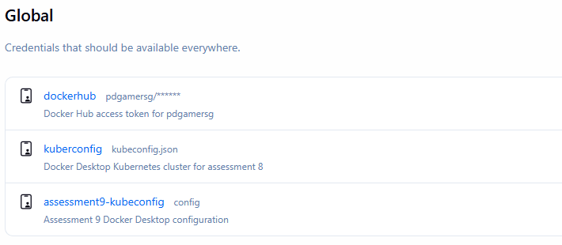
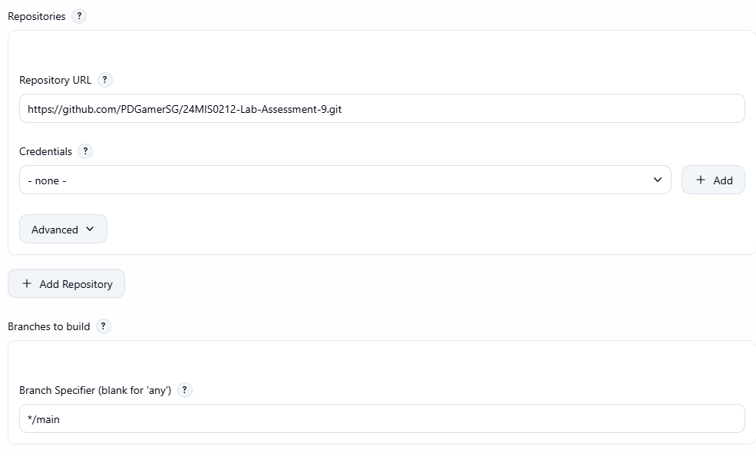
Step 4: Stage View
The pipeline clones the code, builds and tests the Docker image, pushes the versioned image to Docker Hub, deploys to Kubernetes and checks the NodePort and Pods.
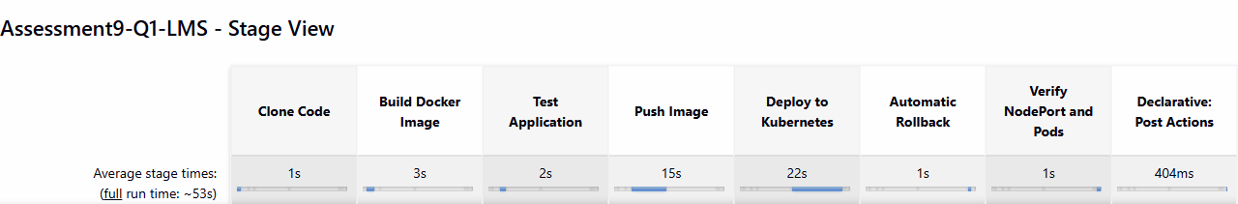
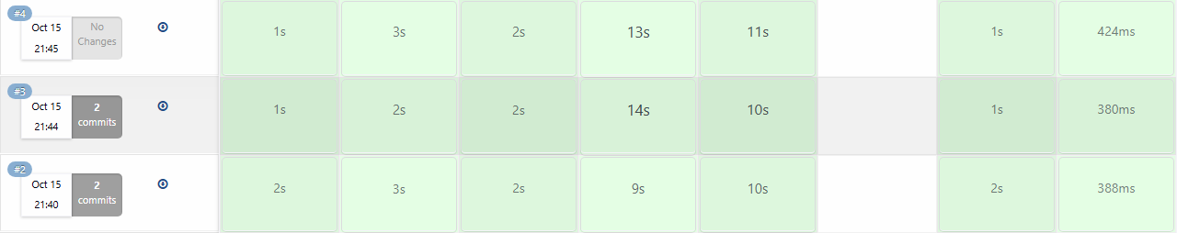
The green rows show successful builds #4, #3 and #2. Build #4 uses pdgamersg/assessment9-lms:v2-4.
Local Docker test:
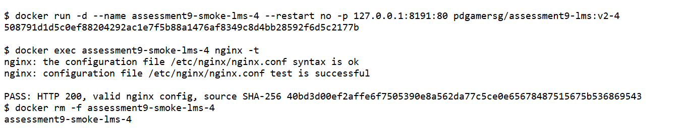
Step 5: Output
Docker Desktop Kubernetes was enabled. The application uses 2 serving replicas, readiness and liveness checks, and NodePort 30081.
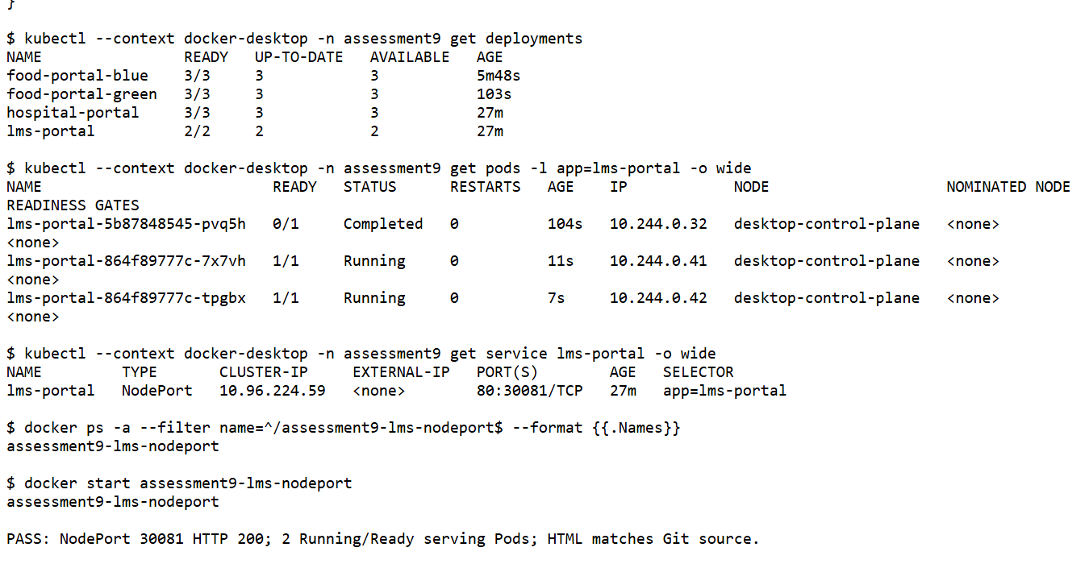
Docker Hub push and image digest:
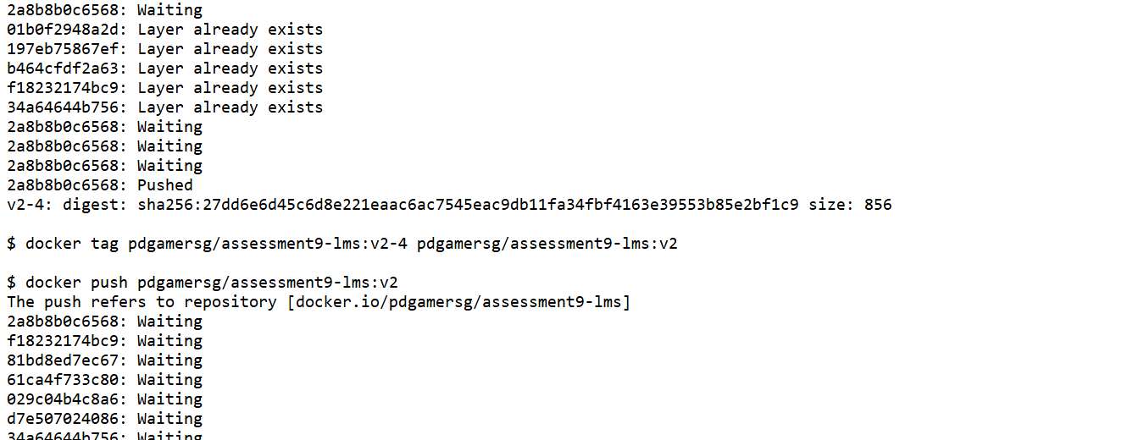
Step 6: Html output
The application was verified through http://localhost:30081. The NodePort returned HTTP 200, and the served HTML matched the checked-out Git source.
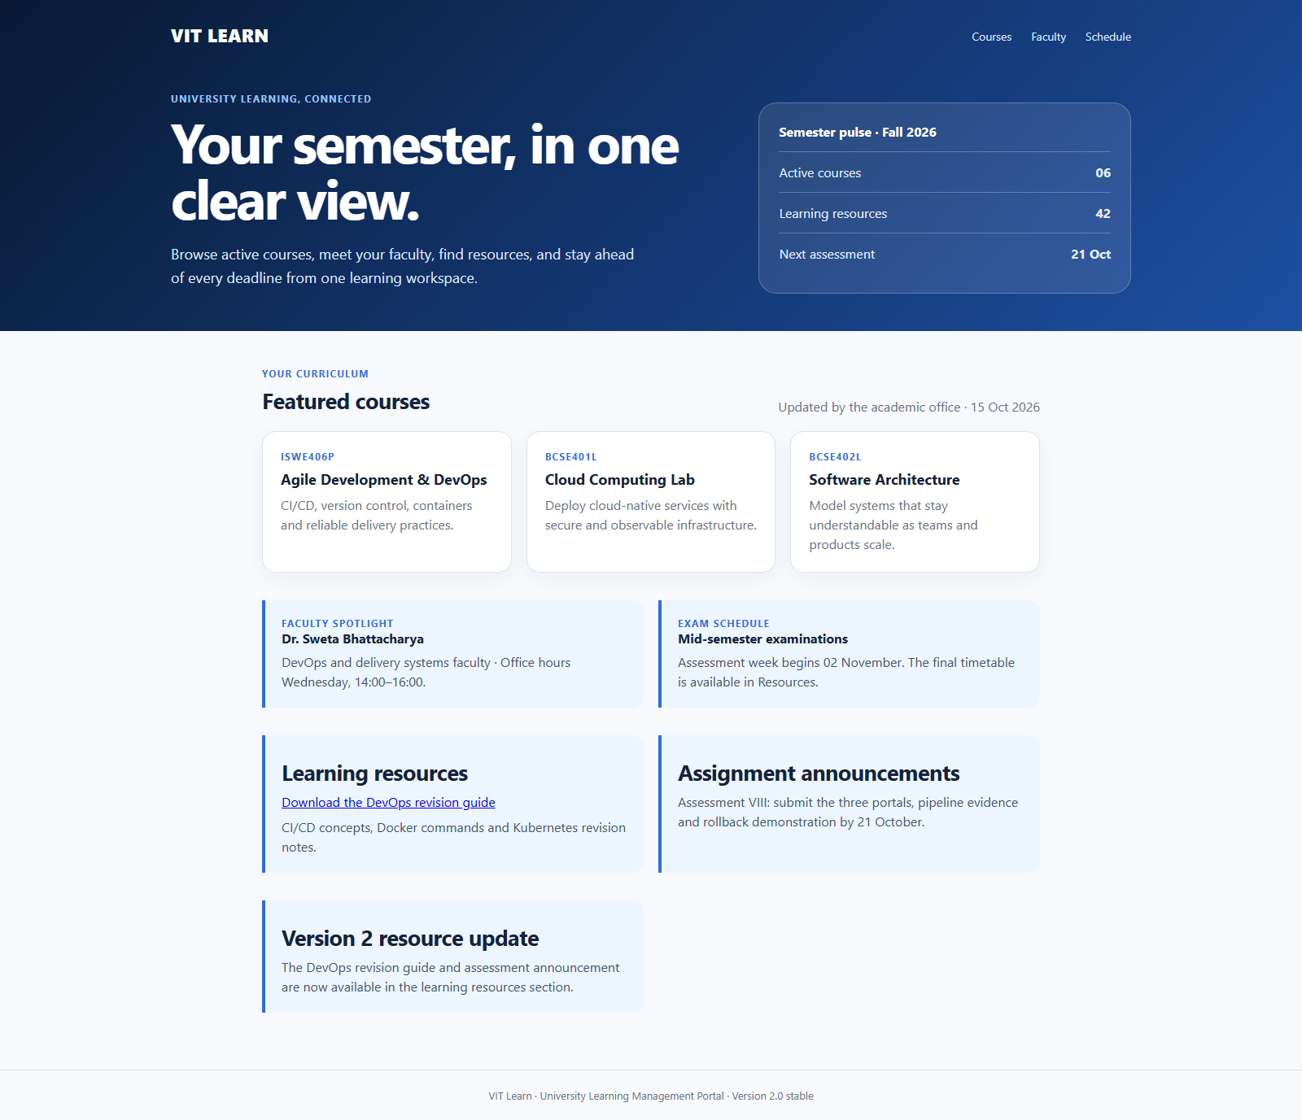
Step 7: Versioned release and health checks
Each Jenkins build publishes a unique version tag. Kubernetes retains five deployment revisions. The /healthz readiness endpoint prevents an unhealthy container from receiving traffic.
The second release adds the learning resource update. Both LMS Pods were Running and Ready after deployment.
Jenkins build #3 was started by an SCM change and deployed the updated source successfully.
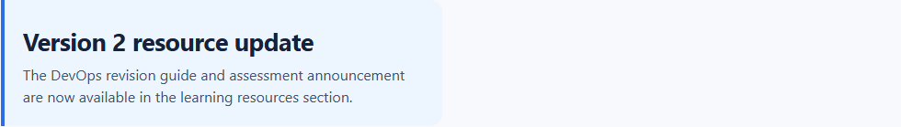
Automatic SCM-triggered build:
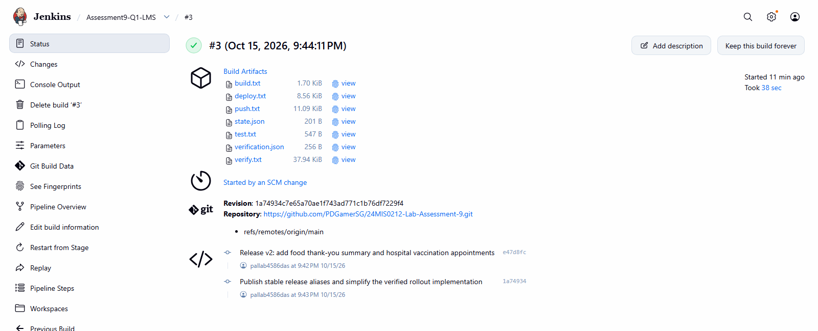
Result: The updated application was deployed successfully and verified through its assigned NodePort.
Question 2:
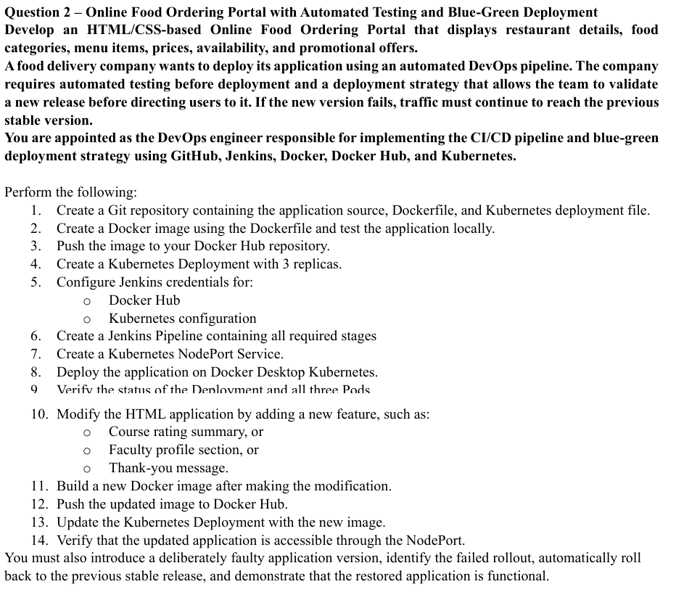
Github Url: https://github.com/PDGamerSG/24MIS0212-Lab-Assessment-9
Step 1: Writing the code
Online Food Ordering Portal was created using HTML and CSS. The source, Dockerfile, Kubernetes files and Jenkinsfile are stored in the food-portal folder.
Code: deployment.yaml file
apiVersion: apps/v1
kind: Deployment
metadata:
name: food-portal-blue
namespace: assessment9
spec:
replicas: 3
revisionHistoryLimit: 5
progressDeadlineSeconds: 60
strategy:
type: RollingUpdate
rollingUpdate: {maxUnavailable: 0, maxSurge: 1}
selector:
matchLabels:
app: food-portal
slot: blue
template:
metadata:
labels:
app: food-portal
slot: blue
spec:
containers:
- name: food-portal
image: pdgamersg/assessment9-food:v2
imagePullPolicy: IfNotPresent
ports:
- containerPort: 80
resources:
requests: {cpu: 10m, memory: 16Mi}
limits: {cpu: 250m, memory: 64Mi}
readinessProbe:
httpGet: {path: /healthz, port: 80}
initialDelaySeconds: 2
periodSeconds: 3
livenessProbe:
httpGet: {path: /healthz, port: 80}
initialDelaySeconds: 5
periodSeconds: 10
service.yaml
apiVersion: v1
kind: Service
metadata:
name: food-portal
namespace: assessment9
spec:
type: NodePort
selector:
app: food-portal
slot: blue
ports:
- port: 80
targetPort: 80
nodePort: 30082
Dockerfile
FROM nginx:1.27-alpine
COPY nginx.conf /etc/nginx/conf.d/default.conf
COPY . /usr/share/nginx/html/
EXPOSE 80
HEALTHCHECK --interval=10s --timeout=3s --retries=3 CMD wget -q -O - http://127.0.0.1/healthz || exit 1
index.html
The page displays restaurant details, food categories, menu items, exact prices, availability and the WELCOME20 promotional offer.
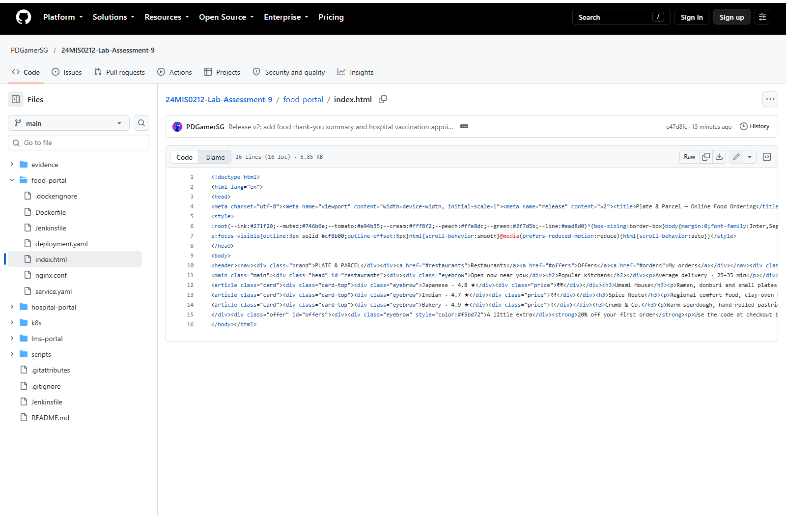
Step 2: Pushing the code to github
One GitHub repository was used for all three questions. The main branch contains the application files and the complete CI/CD implementation.
Commands used:
git add .
git commit -m "Implement reliable portal delivery"
git push origin main
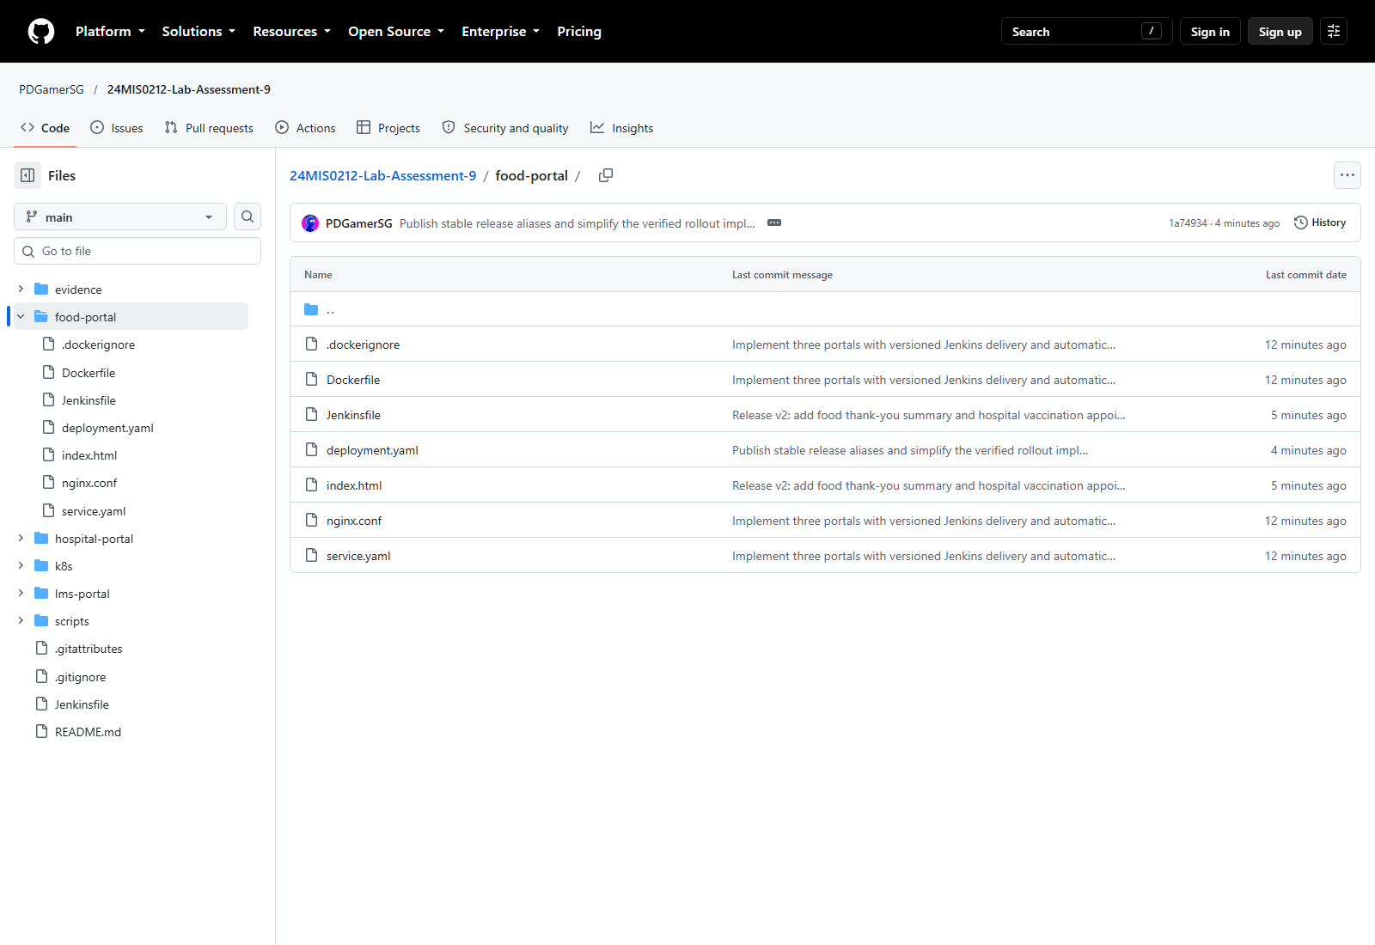
Step 3: Setting up Jenkins
Jenkins uses dockerhub for Docker Hub and assessment9-kubeconfig for Kubernetes. It reads main and polls GitHub every two minutes.
The script path is food-portal/Jenkinsfile. APP selects the portal, and RELEASE sets the image tag prefix.
Step 4: Stage View
The pipeline clones the code, builds and tests the Docker image, pushes the versioned image to Docker Hub, deploys to Kubernetes and checks the NodePort and Pods.
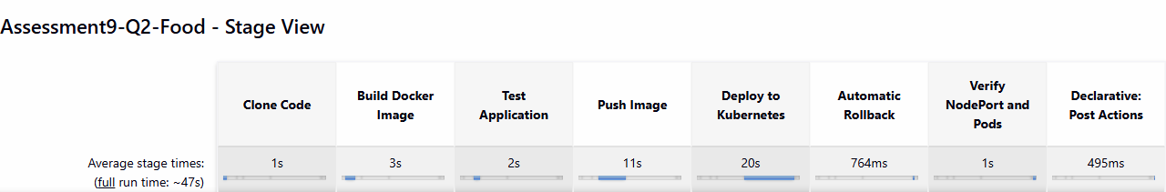
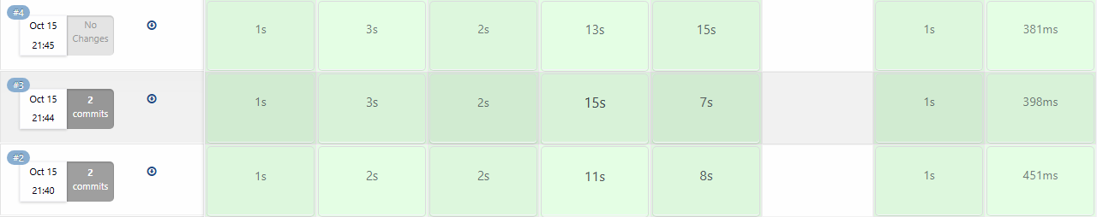
The green rows show successful builds #4, #3 and #2. Build #4 uses pdgamersg/assessment9-food:v2-4.
Local Docker test:
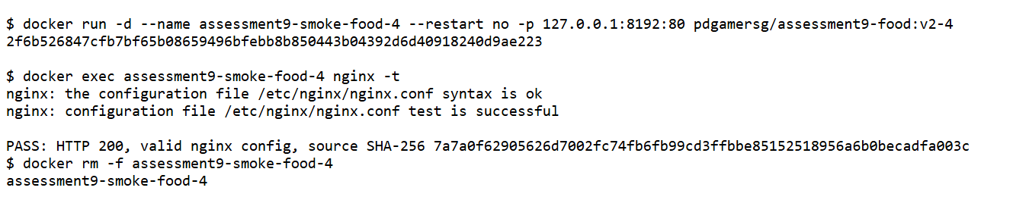
Step 5: Output
Docker Desktop Kubernetes was enabled. The application uses 3 serving replicas, readiness and liveness checks, and NodePort 30082.
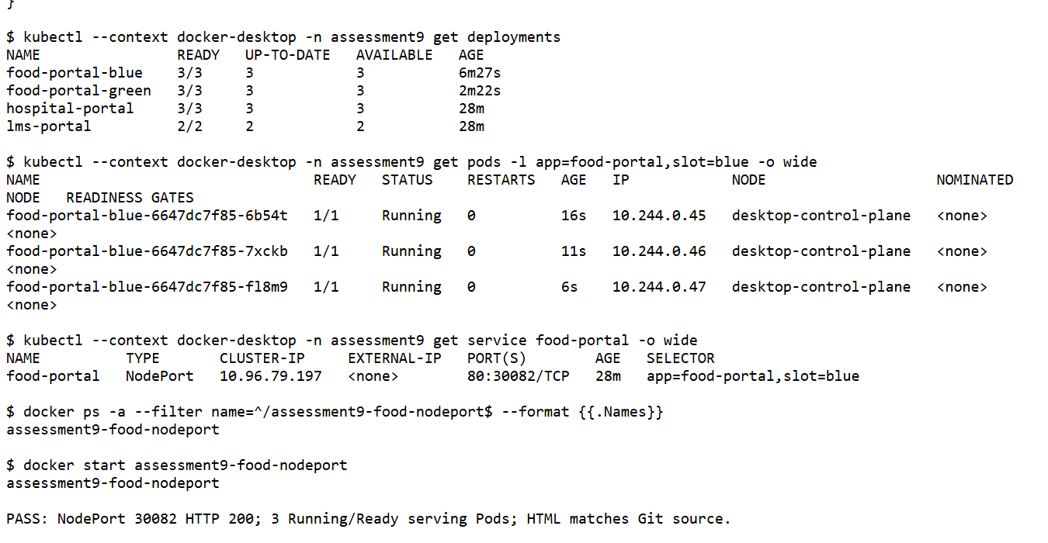
Docker Hub push and image digest:
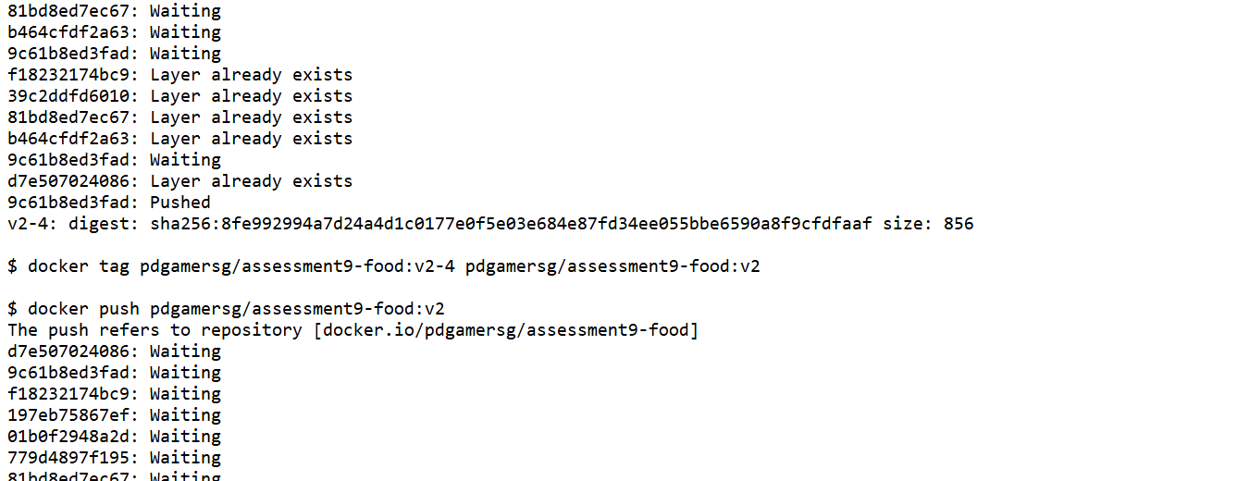
Step 6: Html output
The application was verified through http://localhost:30082. The NodePort returned HTTP 200, and the served HTML matched the checked-out Git source.
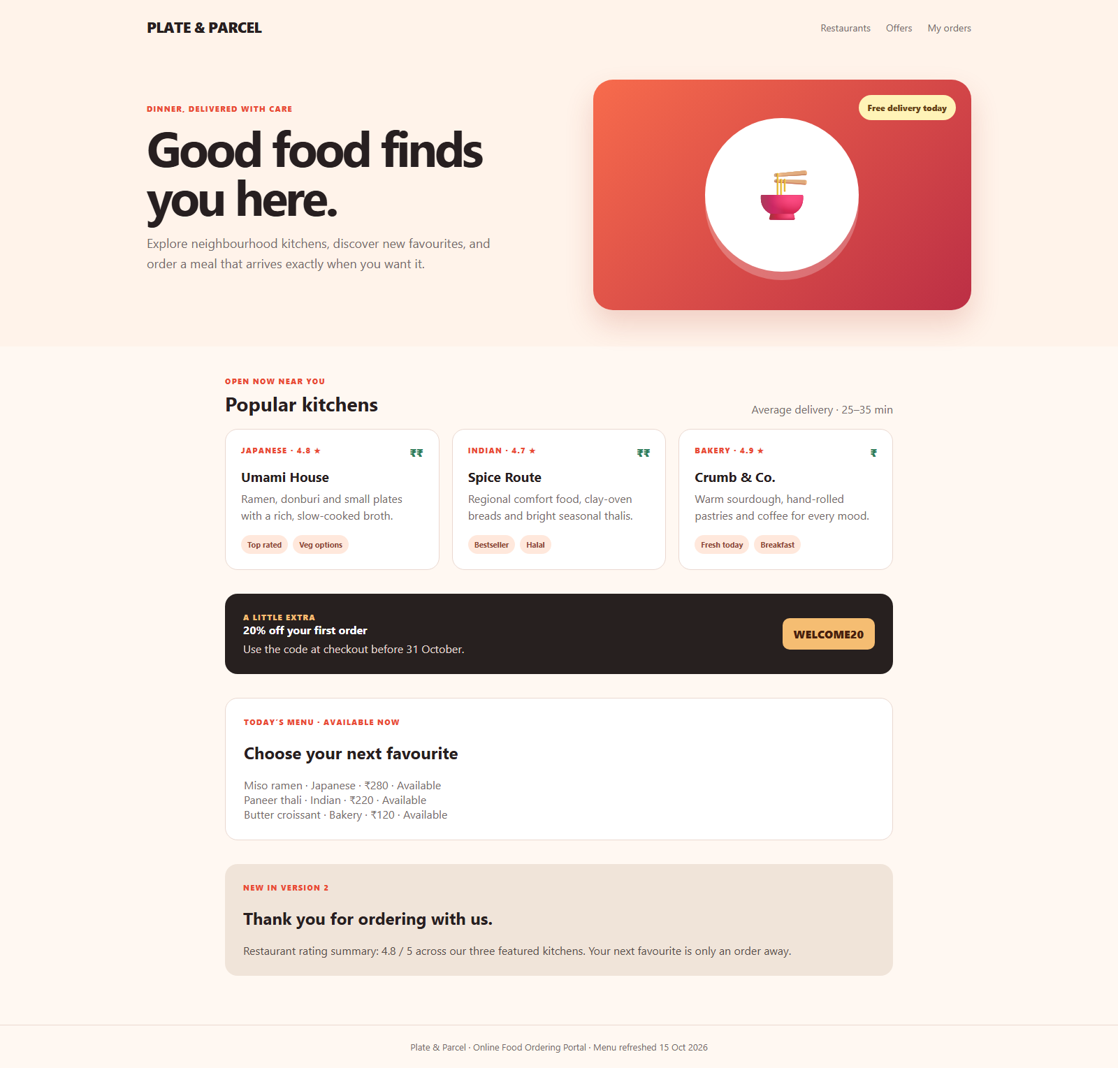
Step 7: Updating the application using blue-green deployment
The updated page adds a thank-you message and a restaurant rating summary. Jenkins deployed the inactive colour with three replicas and waited for its health checks before changing the production Service selector.
Each colour has three Pods. The NodePort selects only the active colour; the other healthy colour remains available as a fallback.
Jenkins build #3 was started by an SCM change and deployed the updated source successfully.
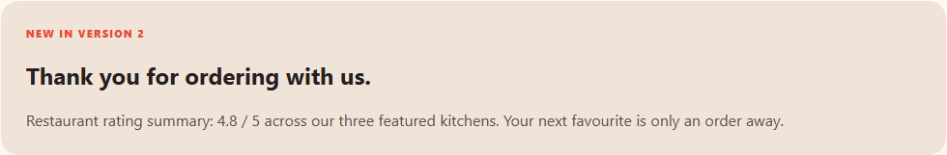
Healthy candidate promoted to blue:
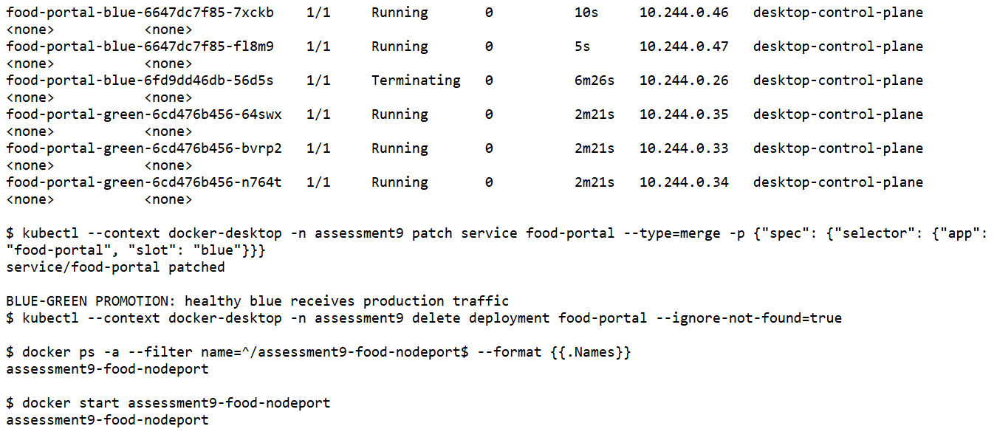
Result: The updated application was deployed successfully and verified through its assigned NodePort.
Question 3:
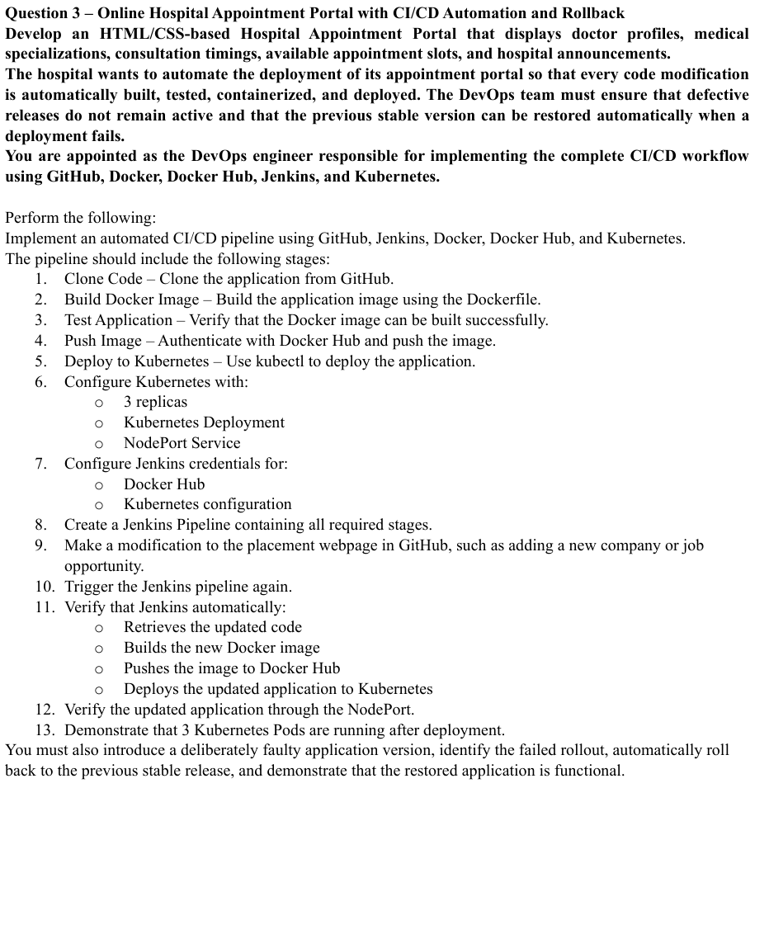
Github Url: https://github.com/PDGamerSG/24MIS0212-Lab-Assessment-9
Step 1: Writing the code
Hospital Appointment Portal was created using HTML and CSS. The source, Dockerfile, Kubernetes files and Jenkinsfile are stored in the hospital-portal folder.
Code: deployment.yaml file
apiVersion: apps/v1
kind: Deployment
metadata:
name: hospital-portal
namespace: assessment9
spec:
replicas: 3
revisionHistoryLimit: 5
progressDeadlineSeconds: 60
strategy:
type: RollingUpdate
rollingUpdate: {maxUnavailable: 0, maxSurge: 1}
selector:
matchLabels:
app: hospital-portal
template:
metadata:
labels:
app: hospital-portal
spec:
containers:
- name: hospital-portal
image: pdgamersg/assessment9-hospital:v2
imagePullPolicy: IfNotPresent
ports:
- containerPort: 80
resources:
requests: {cpu: 10m, memory: 16Mi}
limits: {cpu: 250m, memory: 64Mi}
readinessProbe:
httpGet: {path: /healthz, port: 80}
initialDelaySeconds: 2
periodSeconds: 3
livenessProbe:
httpGet: {path: /healthz, port: 80}
initialDelaySeconds: 5
periodSeconds: 10
service.yaml
apiVersion: v1
kind: Service
metadata:
name: hospital-portal
namespace: assessment9
spec:
type: NodePort
selector:
app: hospital-portal
ports:
- port: 80
targetPort: 80
nodePort: 30083
Dockerfile
FROM nginx:1.27-alpine
COPY nginx.conf /etc/nginx/conf.d/default.conf
COPY . /usr/share/nginx/html/
EXPOSE 80
HEALTHCHECK --interval=10s --timeout=3s --retries=3 CMD wget -q -O - http://127.0.0.1/healthz || exit 1
index.html
The page displays doctor profiles, specialisations, consultation details, appointment slots and hospital announcements.
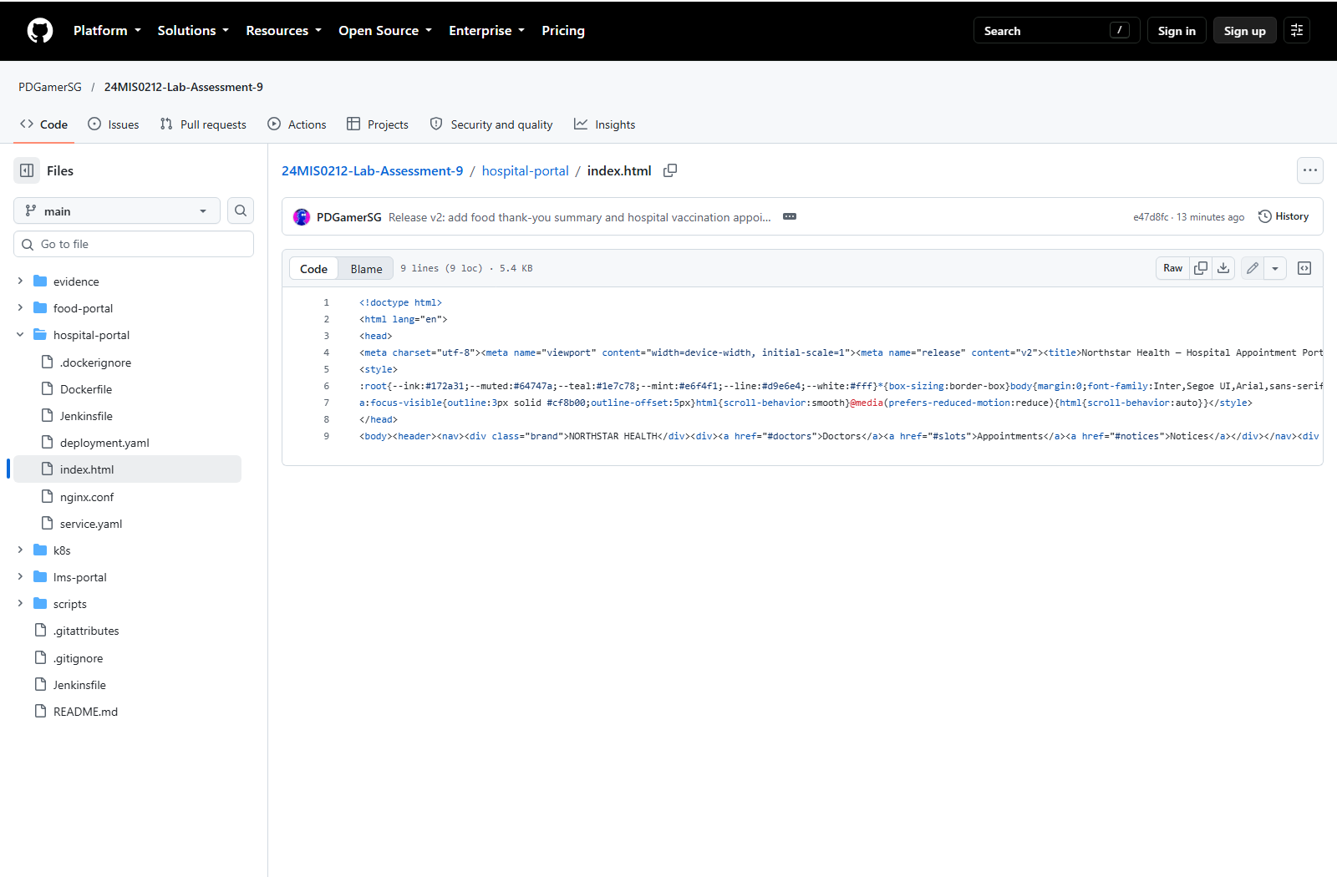
Step 2: Pushing the code to github
One GitHub repository was used for all three questions. The main branch contains the application files and the complete CI/CD implementation.
Commands used:
git add .
git commit -m "Implement reliable portal delivery"
git push origin main
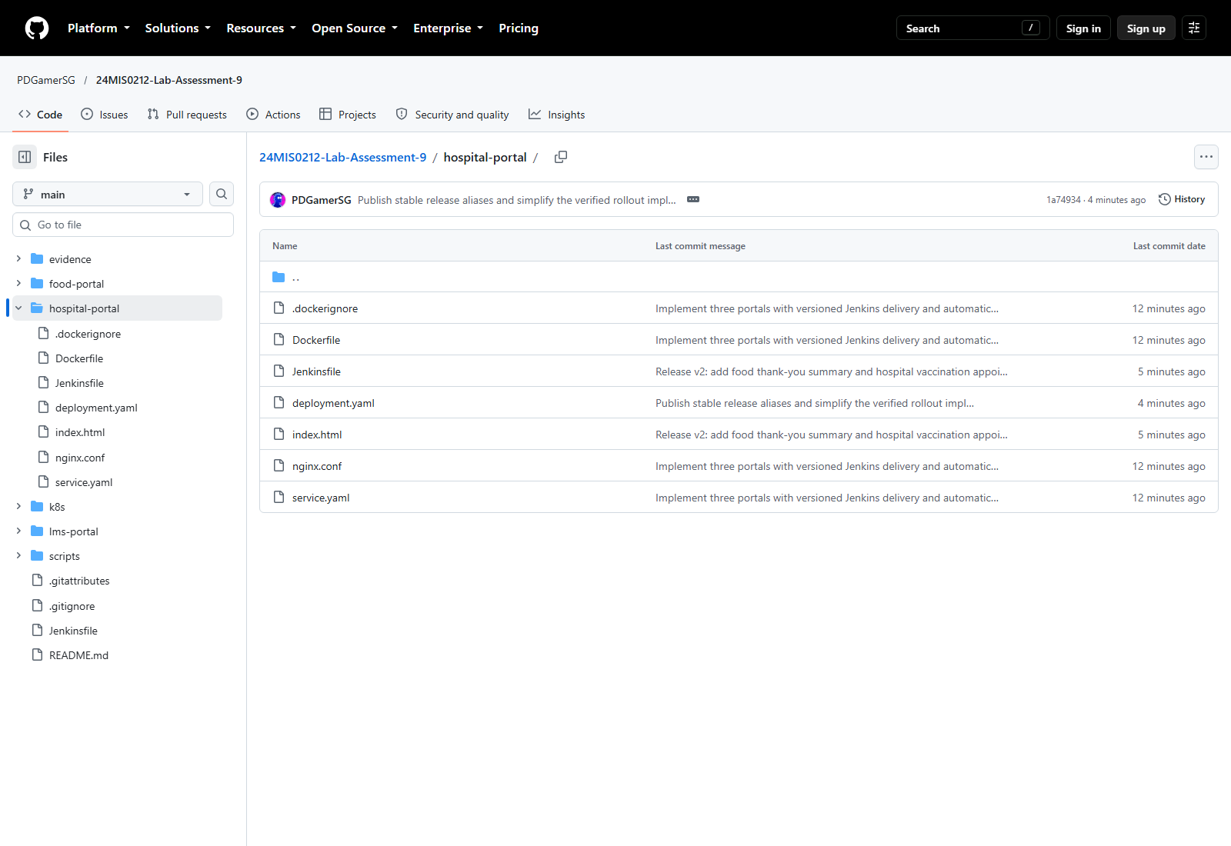
Step 3: Setting up Jenkins
Jenkins uses dockerhub for Docker Hub and assessment9-kubeconfig for Kubernetes. It reads main and polls GitHub every two minutes.
The script path is hospital-portal/Jenkinsfile. APP selects the portal, and RELEASE sets the image tag prefix.
Step 4: Stage View
The pipeline clones the code, builds and tests the Docker image, pushes the versioned image to Docker Hub, deploys to Kubernetes and checks the NodePort and Pods.
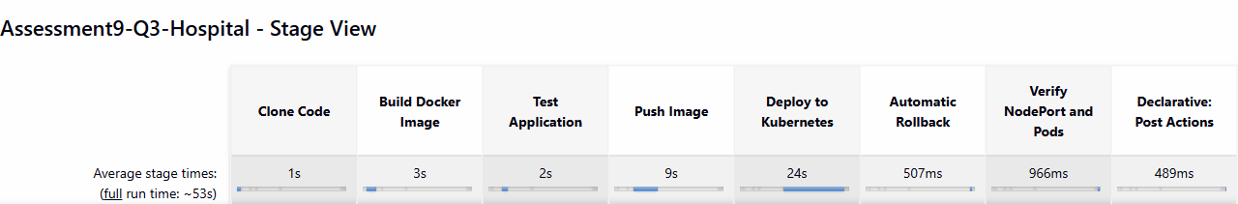
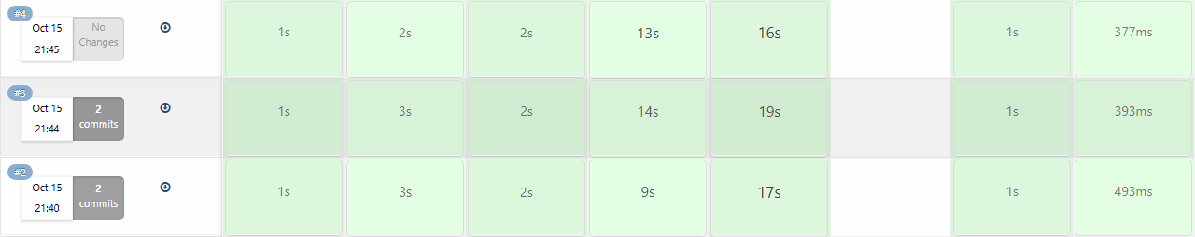
The green rows show successful builds #4, #3 and #2. Build #4 uses pdgamersg/assessment9-hospital:v2-4.
Local Docker test:
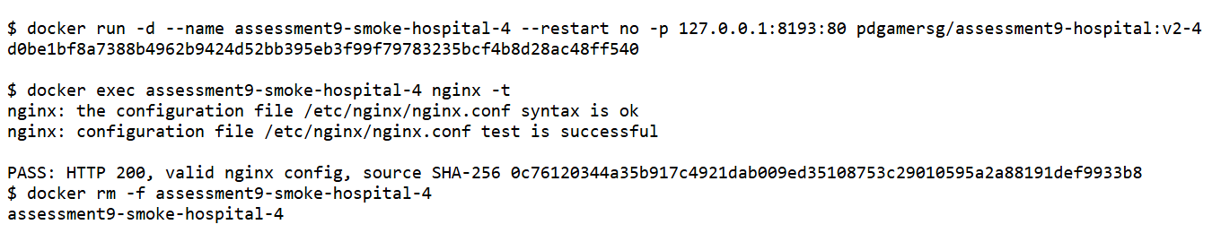
Step 5: Output
Docker Desktop Kubernetes was enabled. The application uses 3 serving replicas, readiness and liveness checks, and NodePort 30083.
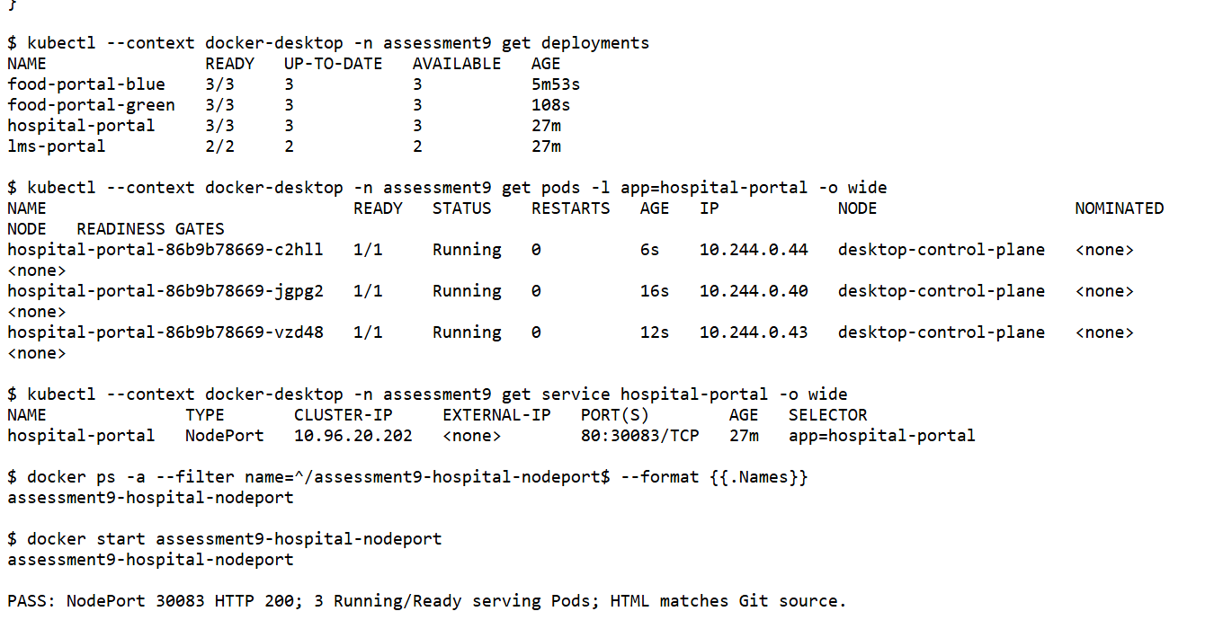
Docker Hub push and image digest:
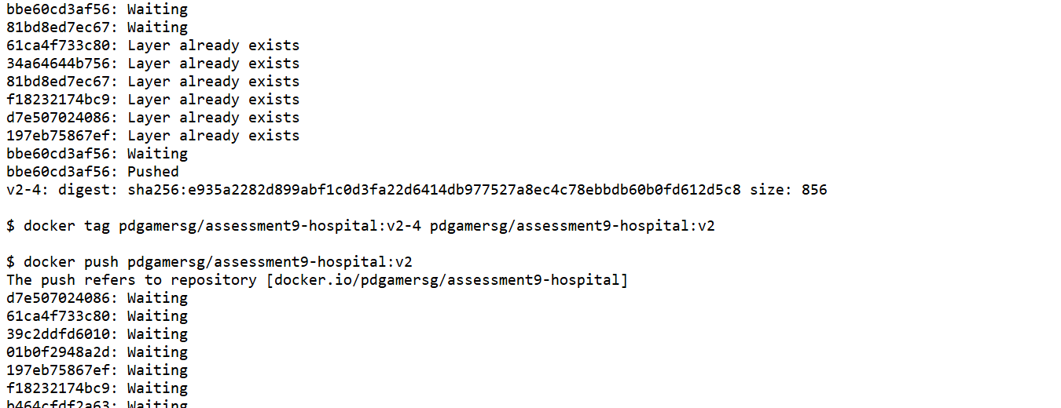
Step 6: Html output
The application was verified through http://localhost:30083. The NodePort returned HTTP 200, and the served HTML matched the checked-out Git source.
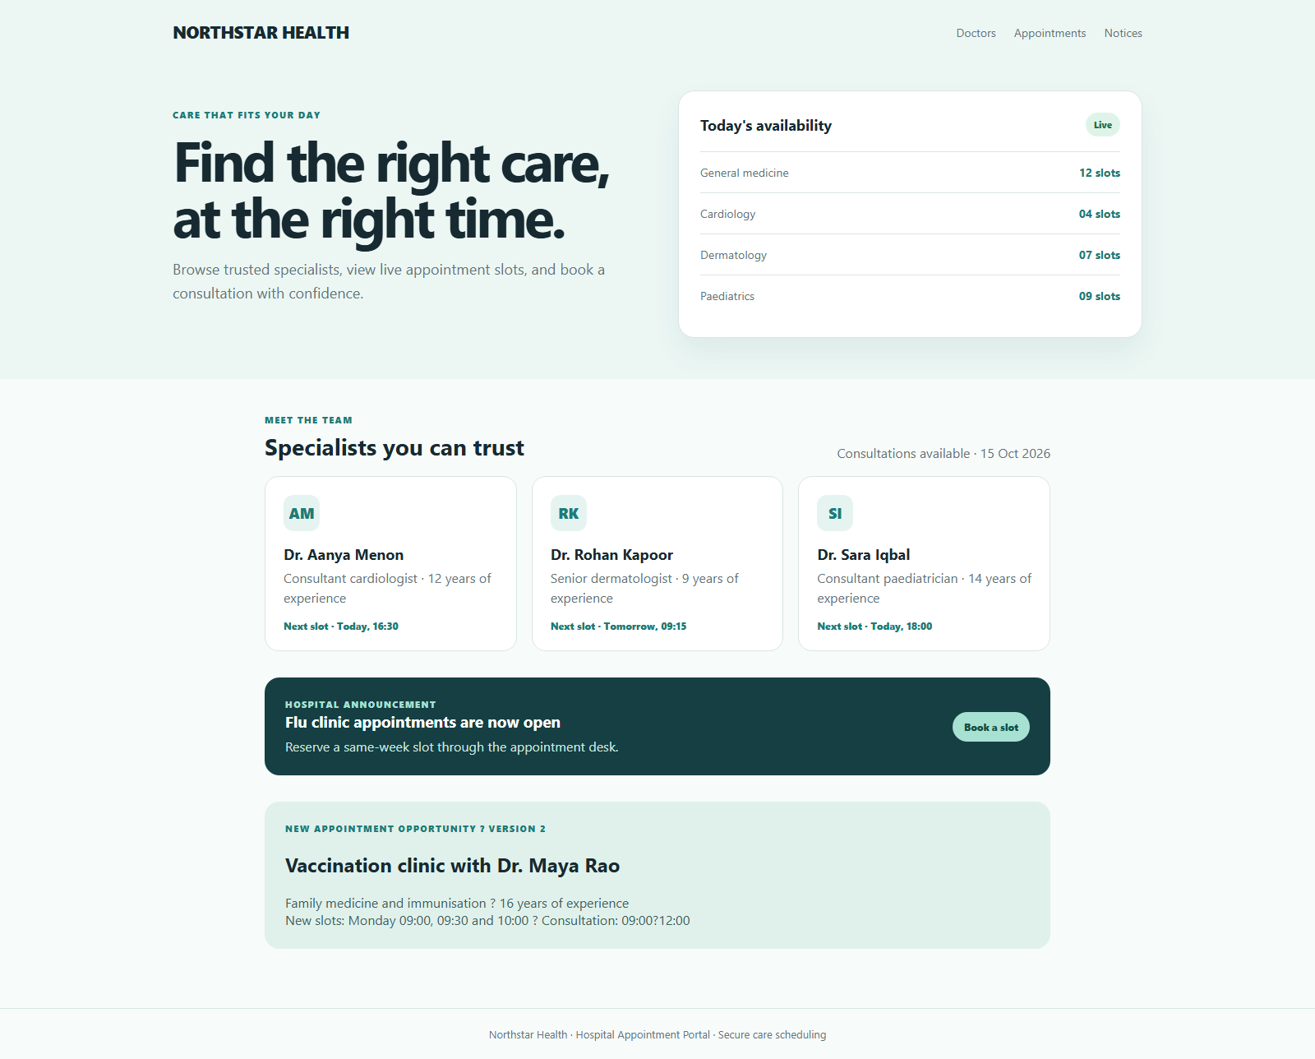
Step 7: Updating the hospital portal
The update adds a vaccination clinic with Dr. Maya Rao, consultation timings and three appointment slots. The GitHub commit was detected automatically by Jenkins SCM polling.
The prompt refers to a placement webpage in this step. The change was applied to the hospital portal, consistent with the Question 3 scenario.
Jenkins build #3 was started by an SCM change and deployed the updated source successfully.
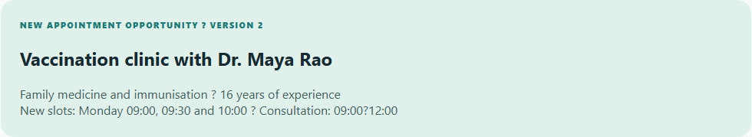
Automatic SCM-triggered build:
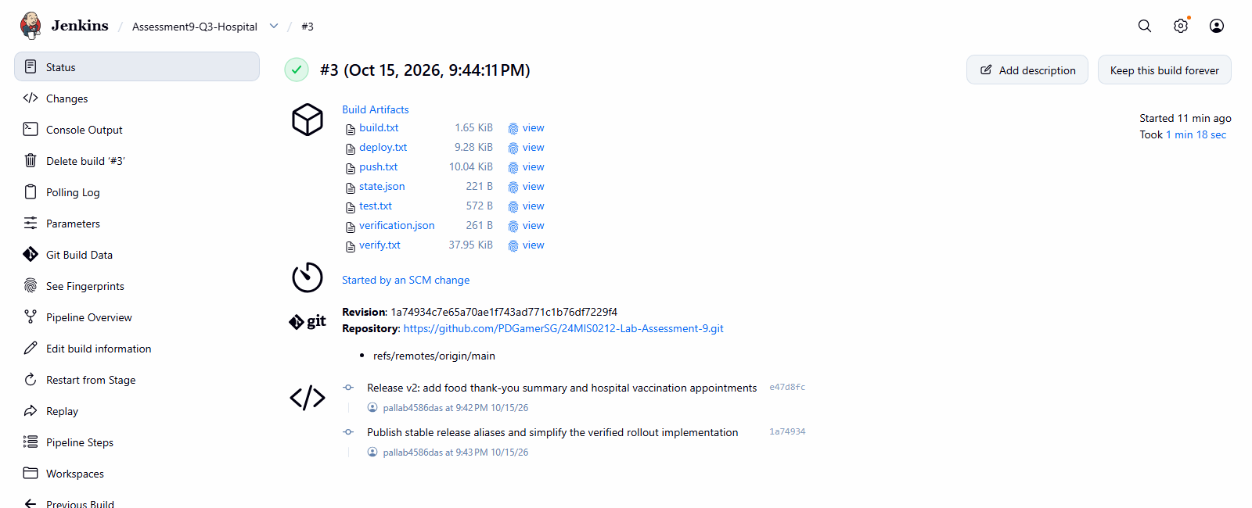
Result: The updated application was deployed successfully and verified through its assigned NodePort.

